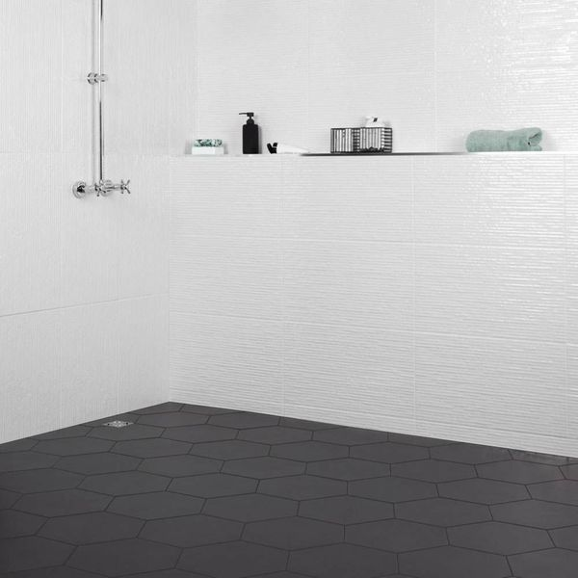**Aspect Black Hexagon Tiles:**

## **Product Description**

Add a dark and contemporary appearance to your home this season with these sleek and stylish Black Hexagon Tiles. A smooth porcelain hexagon tile with a matt finish, they belong to our range of Aspect Hexagon Tiles and are suitable for use on both walls and floors. Inject some six-sided style into your home this season.

## **Product Info**

* Product ID: 14550
* Tiles Per SQM: 14.310684840116
* Sale by: Per SQM
* Size: 330x285x9mm
* Weight: 1.67 KG
* Material Type: Porcelain
* Finish: Matt
* Colour: Black/Charcoal
* Suitability: Floors, Walls
* Grade: 3
* Rectified Edge: No
* Underfloor Heating: Yes
* Thickness (mm): 9